**Exercise 1 : Setting up JUnit**

We can directly setup Jar in VS Code with the help of VS Code Extension such as **Extension Pack for Java and Test Runner for Java.** After selecting the jar icon on sidebar , click on enable Java Test and it will  **automatically** download all required **Junit Jupiter Test Packages** and add It as **.jar** file in lib folder of source file.

Or manually by these steps

* ****Download JUnit and Hamcrest JARs****
* **Create a** lib/ **Folder in Your Project**
* **Write Java and Test Classes**
* **Import JUnit Classes**
* **Compile with Classpath Using** javac
* **Run Tests with** JUnitCore
* **(Optional) Use VS Code Extensions for Easy Setup**
* **Organize Files Properly for Clean Structure**

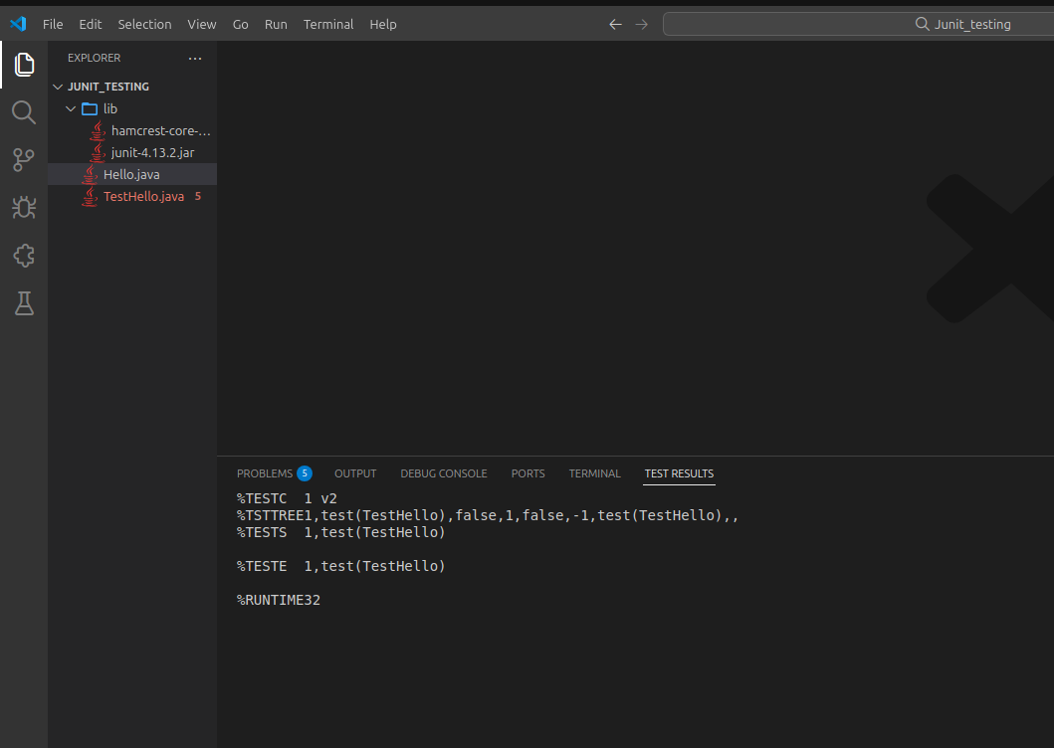

**Output :**